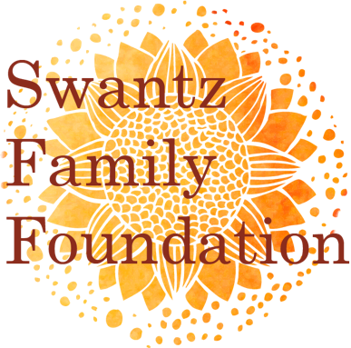

Grantee Report
Deadline: February 15th

- Report Narrative:
  - Provide a brief 1-2 page narrative of your program activities over the past year (as related to the grant received).
  - Outline your objectives for this program. Were your objectives met? How do you know?

- Tell us a story:
  - The Swantz Family Foundation recently joined the Rethink Outside campaign. You can learn more about this campaign and make your own pledge at www.rethinkoutside.org.
  - As part of this campaign, we are looking to create a collection of stories and narratives to document how people are engaging with the outdoors and prioritizing the benefits of time in nature.
  - Please share a short (1-3 paragraph) narrative of how your program has helped young people to connect to and benefit from time in nature. It can be the story of a single participant who had a moving experience, or the story of the collective impact of your program on a group or community. Please note that we will be featuring a collection of these stories on our website and in social media. You may alter names as necessary.
  - Optional: include 1-3 pictures of your program in action.

- Attachments
  - Please include a final program budget showing actual expenses.

Please submit your final report and attachments by email to Jennifer Swantz at swantzff@gmail.com.

