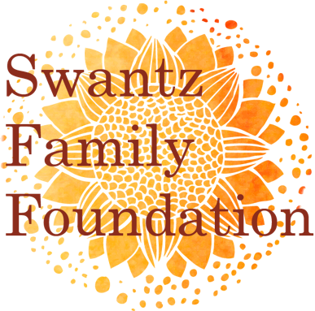

Grant Application and Cover Letter
Application Deadline: March 1st

Date:

Contact Information
Name: Title:
Phone: Email:
Relationship to Organization (staff, volunteer, Board member):

Organization Information
Name:
Address:
Website: Email:
Total Organization Budget:

Project Information
Project Name:
Amount Requested: Total Project Budget:
Project Summary: (Summarize your project request in 1-2 paragraphs. 200 words max.)

Signature of Principal Executive or Volunteer Officer
Printed Name: Title:
Signature: Date:

Proposal
- Proposal Narrative: Proposals should not exceed 4 pages and should clearly set forth the proposed program/project and objectives. Proposals should include:
  - A brief history of the organization, including its mission.
  - A statement of need for the program/project.
  - Goals and objectives for the program/project.
  - A description of activities to achieve the stated goals and objectives.
  - An outline of how the program’s success will be monitored and evaluated.
  - An explanation of how the program would be successful if only partial funding is awarded.

- Attachments
  - Program/project budget, including revenue and expenses. Under revenue, please include other foundations you have applied to for funding.
  - Organizational budget including revenue and expenses.
  - Copy of IRS 501(c)(3) letter of determination.
  - Most recent audit or IRS 990.
  - Optional: brochure, newsletter article or other written material describing program.

Submission Instructions
- Please submit all materials in Word, Excel, or PDF format by email to swantzff@gmail.com on or before March 1st.

- Questions can be directed to Jennifer Swantz, President, at swantzff@gmail.com.

- Upon receipt of the completed proposal, the Foundation may request additional information or schedule a visit.

